Year 12 General Integrated Science Test Revision Name

1. A scientist wants to investigate the relationship between level of salinity and the growth of hibiscus flowers. She set up five pots with one hibiscus plant in each pot. All the plants were of the same height (12cm). In one pot she added water. In the other four pots she added different concentrations of salty water. After three weeks she measured the height of each plant.

Pot | Salt concentration (g/L) | Height of plant (cm)
1 | 0.02 | 19
2 | 0.1 | 17
3 | 0.5 | 16
4 | 1.0 | 14
5 | 2.5 | 12

(i) Write a possible hypothesis for this experiment.

(ii) What are the independent and dependent variables?

Independent:

Dependent:

(iii) Name two variables that she kept the same in her experiment.

(iv) Name two more variables that can be controlled.

(v) How could she have improved the validity of the experiment?

Validity:

(vi) What can be concluded from pot 5 with salt concentration of 3%

(vii) Graph the following data.

Please note: If you need another graph paper turn to page 16.

2. Plants play many important roles in the maintenance of a clean and stable ecosystem. Describe the importance and the process of each of the following roles.

Oxygenation:

Erosion:

3. A farmer wanted to estimate the number of rabbits that have infested his farm. Eh captured 22 in one day and released them. After two weeks he recaptured 35 out of which 12 were tagged from the previous catch. How many rabbits were there on his farm? Show calculations.

4. Explain, using examples, the difference between commensalism and mutualism.

5. Explain what is meant by species diversity.

6. Genetic diversity is made possible using meiosis. Explain two factors that can result in genetic variation.

7. Describe two values of biodiversity and give examples to support your claim.

8. List four local factors that are responsible for reducing biodiversity as a result of human activities, and describe two, using examples.

9. Complete the following diagram of meiosis by drawing missing chromosomes in the blank cells.

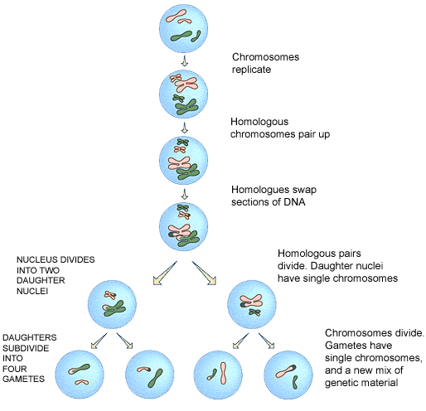

10. Describe the type of adaptation displayed in each image and explain how it helps in the survival of the organism.
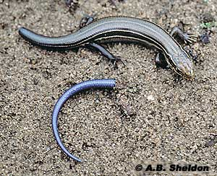
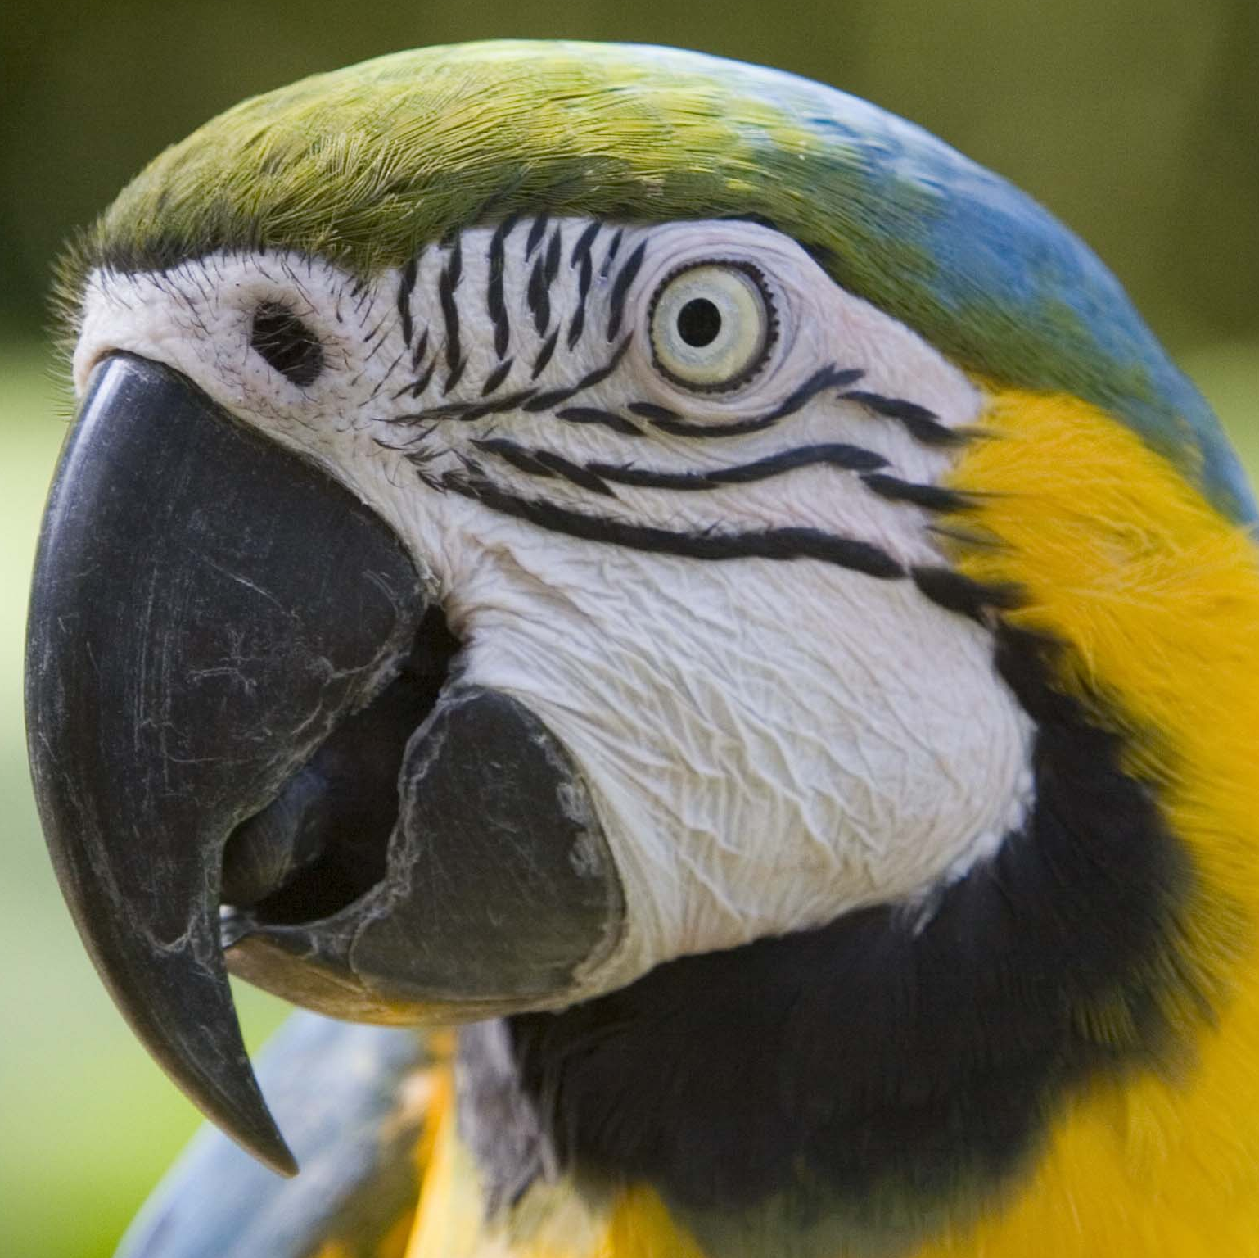
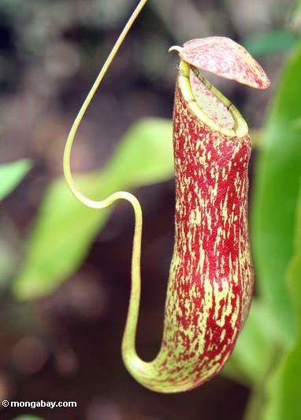

A
B
C

A

B

C

11. Define the term ecosystem.

12. Define the term aquaculture.

13. Explain the term ‘eutrophication’.

14. Write an equation of a chemical process utilised by the plant to produce oxygen.

15. Identify the mode of interaction in each of the following scenarios.

- The remora fish swim close the leopard shark to obtain food scraps.

- Sea anemone gives protection to clown fish and in return receives food scraps from the fish.

- An isopod living inside the fish and eats everything the fish eats.

- Birds eating insects from the hide of a giraffe.

- Hermit crab gives a ride to a sea anemone on its shell.

16. Write a chemical equation that represents the chemical process by which plants give us food.

17. Describe four uses of plants that can contribute to a stable ecosystem.

18. Human activities have impacted on the Amazon ecosystem.

a) Identify a practice that is resulting in a reduced genetic biodiversity.

b) Identify a practice that is resulting in pollution.

c) Identify a practice that is resulting in destruction of habitats.

19. Identify a method that can be used to conserve biodiversity and describe how it works in protecting biodiversity.

20. A biologist counted the number of beetles in his sugar cane field. He used the quadrat method. In one quadrat he counted 5 beetles. In another quadrat he counted 4 beetles, and in a third quadrat he counted 6 beetles. Each quadrat measures 1m². If the whole area of the field is 1000m², calculate: (show working out)

- The number of beetles in his field.

- The density of the beetles in his field.

21. Look at the diagram below. What process is this diagram illustrating? Explain what is happening using scientific terminologies.

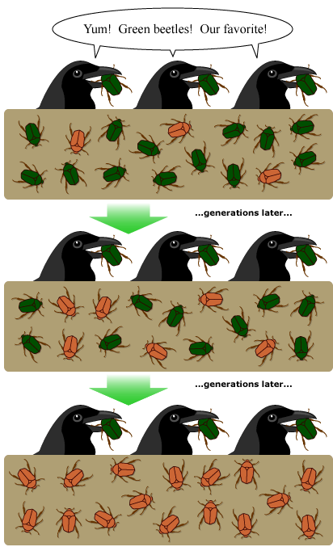

END

